OSSP (Operating Systems And Systems Programming) - 25CS2104E

WEEK:7

Write a program that prints the addresses of code, global, static, heap, and stack variables. Analyze the Linux process address space layout and explain each memory segment.

Make use of the /proc//maps file and memory analysis tools to study the memory organization of a running process. Prepare a report explaining virtual memory mappings.

WEEK:8

Develop a program using malloc(), calloc(), realloc(), and free(). Monitor memory allocation behavior and identify memory leaks using Valgrind.

Develop a program that demonstrates Copy-on-Write behavior after a fork(). Analyze memory usage before and after modifying data in the child process.

Week_7:
CODE:
#include <stdio.h>
#include <stdlib.h>
int global_var = 10;
void code_function()
{
printf("Code segment address : %p\n", (void *)code_function);
}
int main()
{
static int static_var = 20;
int stack_var = 30;
int *heap_var;
heap_var = malloc(sizeof(int));
if (heap_var == NULL)
{
printf("Memory allocation failed.\n");
return 1;
}
*heap_var = 40;
printf("Linux Process Address Space\n\n");
code_function();
printf("Global variable address: %p\n", (void *)&global_var);
printf("Static variable address: %p\n", (void *)&static_var);
printf("Heap variable address : %p\n", (void *)heap_var);
printf("Stack variable address : %p\n", (void *)&stack_var);
printf("\nValues:\n");
printf("Global : %d\n", global_var);
printf("Static : %d\n", static_var);
printf("Heap : %d\n", *heap_var);
printf("Stack : %d\n", stack_var);
free(heap_var);
return 0;
}
OUTPUT:
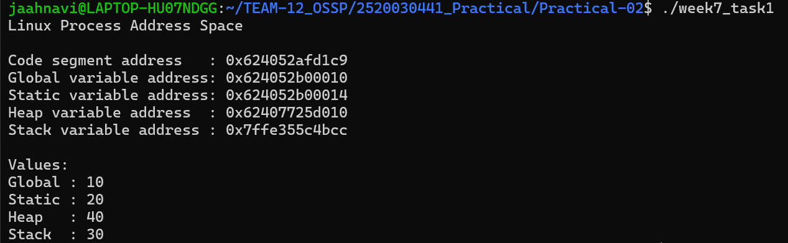
Task 2
CODE
#include <stdio.h>
#include <unistd.h>
int main()
{
printf("Memory Mapping Analysis Program\n");
printf("Process PID: %d\n\n", getpid());
printf("Reading /proc/%d/maps\n\n", getpid());
FILE *file;
char line[256];
char path[100];
snprintf(path, sizeof(path), "/proc/%d/maps", getpid());
file = fopen(path, "r");
if (file == NULL)
{
perror("Unable to open /proc/maps");
return 1;
}
while (fgets(line, sizeof(line), file))
{
printf("%s", line);
}
fclose(file);
printf("\nMemory mapping analysis completed.\n");
return 0;
}
OUTPUT
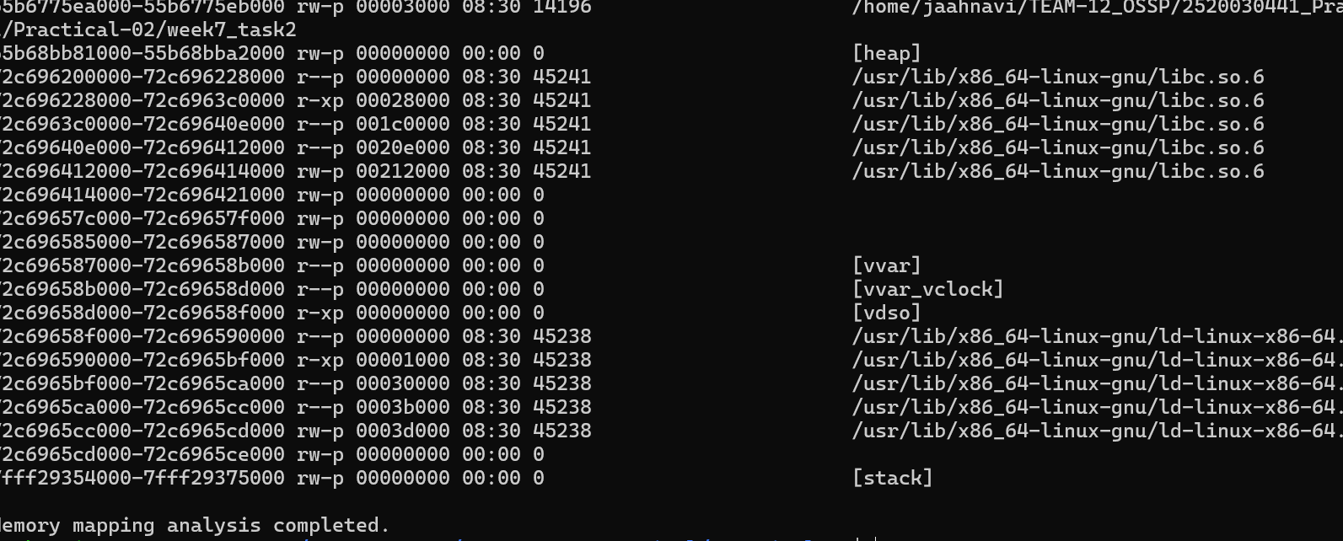

WEEK_8
CODE
#include <stdio.h>
#include <stdlib.h>

int main()
{
int i;
int *malloc_array;
int *calloc_array;
int *temp;

printf("Dynamic Memory Allocation Program\n\n");

malloc_array = malloc(3 * sizeof(int));

if (malloc_array == NULL)
{
printf("malloc() failed.\n");
return 1;
}

for (i = 0; i < 3; i++)
malloc_array[i] = (i + 1) * 10;

printf("malloc() allocated 3 integers: ");
for (i = 0; i < 3; i++)
printf("%d ", malloc_array[i]);
printf("\n");

calloc_array = calloc(3, sizeof(int));

if (calloc_array == NULL)
{
printf("calloc() failed.\n");
free(malloc_array);
return 1;
}

printf("calloc() allocated 3 integers: ");
for (i = 0; i < 3; i++)
printf("%d ", calloc_array[i]);
printf("\n");

temp = realloc(malloc_array, 5 * sizeof(int));

if (temp == NULL)
{
printf("realloc() failed.\n");
free(malloc_array);
free(calloc_array);
return 1;
}

malloc_array = temp;

for (i = 3; i < 5; i++)
malloc_array[i] = (i + 1) * 10;

printf("realloc() resized array to 5 integers: ");
for (i = 0; i < 5; i++)
printf("%d ", malloc_array[i]);
printf("\n");

free(malloc_array);
free(calloc_array);

printf("\nfree() released all allocated memory.\n");
printf("Memory allocation and deallocation completed successfully.\n");

return 0;
}
OUTPUT
==1234== HEAP SUMMARY:
==1234== in use at exit: 0 bytes in 0 blocks
==1234== total heap usage: 3 allocs, 3 frees, 56 bytes allocated
==1234==
==1234== All heap blocks were freed -- no leaks are possible
==1234==
==1234== LEAK SUMMARY:
==1234== definitely lost: 0 bytes in 0 blocks
==1234== indirectly lost: 0 bytes in 0 blocks
==1234== possibly lost: 0 bytes in 0 blocks
==1234== still reachable: 0 bytes in 0 blocks
==1234== suppressed: 0 bytes in 0 blocks
==1234==
==1234== ERROR SUMMARY: 0 errors from 0 contexts (suppressed: 0 from 0)

TASK 2
CODE
#include <stdio.h>
#include <stdlib.h>
#include <unistd.h>
#include <sys/wait.h>

#define SIZE 1000000

int data[SIZE];

int main()
{
pid_t pid;

printf("Copy-on-Write Demonstration\n\n");

printf("Parent PID: %d\n", getpid());
printf("Address of data: %p\n", (void *)data);

data[0] = 10;

printf("Before fork: data[0] = %d\n", data[0]);

pid = fork();

if (pid < 0)
{
perror("fork failed");
return 1;
}

if (pid == 0)
{
printf("\nChild Process\n");
printf("Child PID: %d\n", getpid());
printf("Data before modification: %d\n", data[0]);

data[0] = 50;

printf("Data after modification: %d\n", data[0]);
printf("Child modified its private copy of the data.\n");

exit(0);
}
else
{
wait(NULL);

printf("\nParent Process\n");
printf("Parent PID: %d\n", getpid());
printf("Data after child modification: %d\n", data[0]);
printf("Parent data remains unchanged due to Copy-on-Write.\n");
}

return 0;
}
OUTPUT
Copy-on-Write Demonstration

Parent PID: 1450
Address of data: 0x55a1c3f04040
Before fork: data[0] = 10

Child Process
Child PID: 1451
Data before modification: 10
Data after modification: 50
Child modified its private copy of the data.

Parent Process
Parent PID: 1450
Data after child modification: 10
Parent data remains unchanged due to Copy-on-Write.

